**Lab Exercise 8– Creating a VPC in Terraform Objective: Steps:**

**1. Create a Terraform Directory:**

**mkdir terraform-vpc cd terraform-vpc**

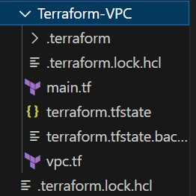

* Create Terraform Configuration Files:
* Create a file named main.tf: # main.tf

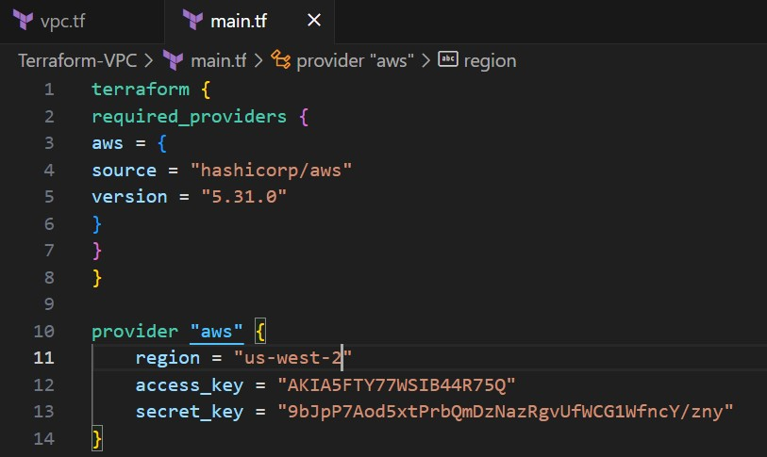

#vpc.tf

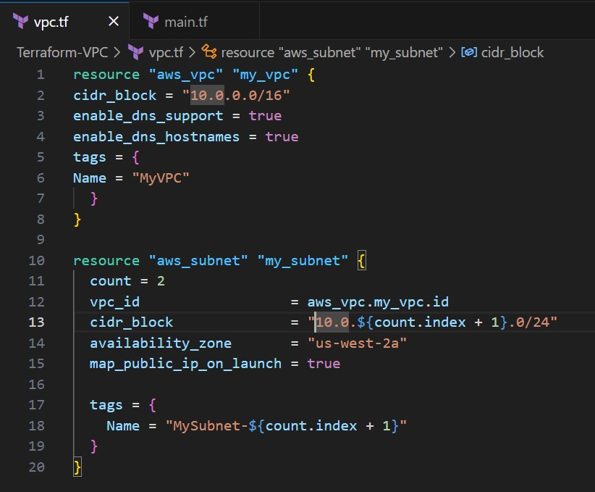

**2.Initialize and Apply:**

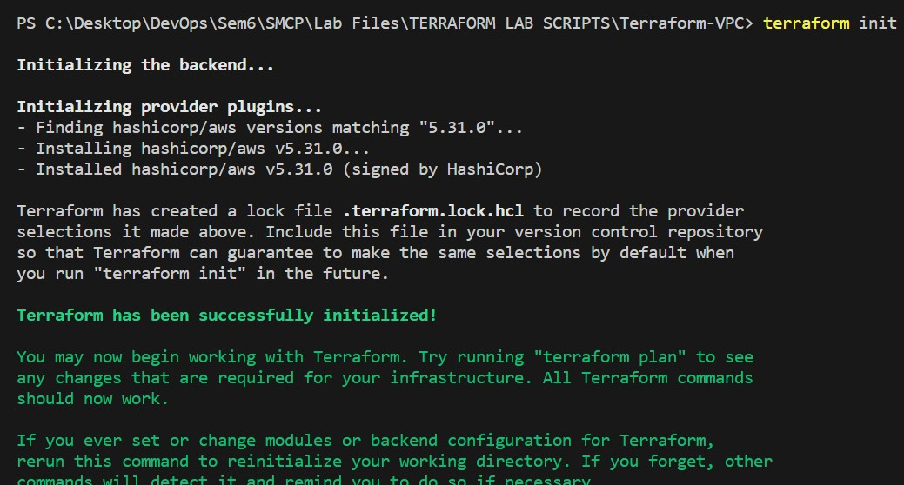

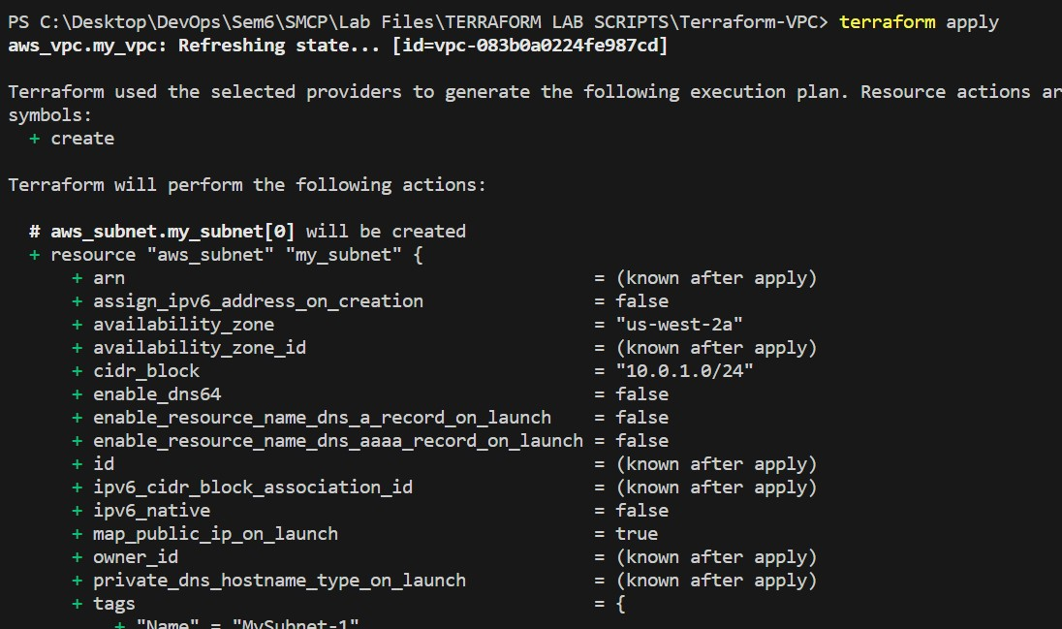

**3.Verify Resources in AWS Console:**

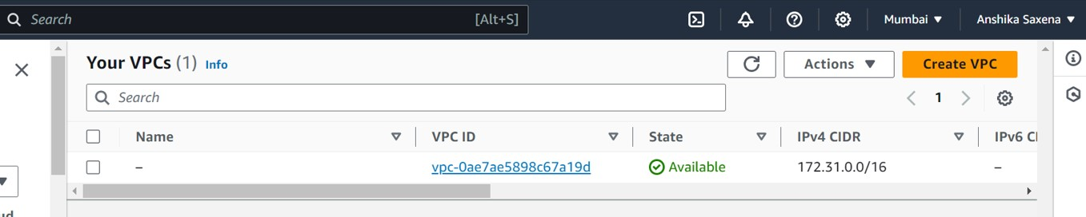

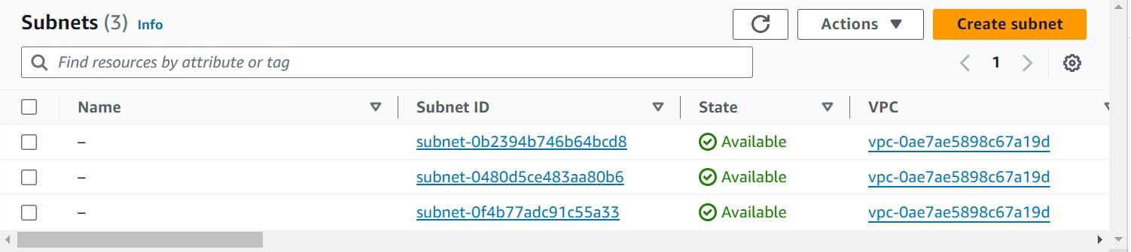

**4.Clean Up:**

**terraform destroy**

